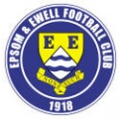 | Epsom & Ewell F.C.  7  v  Bedfont Sports  Saturday, 11th October 2014
For our League match this afternoon we welcome the players, officials and followers of Bedfont Sports, along with today's match officials and of course our own regular supporters.

Today’s opponents have now established themselves at this level and in addition possess one of the nicest grounds in the League, which I strongly recommend that you visit if you have not done so previously. We have a good record on their perfect playing surface but in two matches here we have one win each; an Alex McKay header five minutes from time enabling us to win by the only goal last season and the less said about the 4-0 defeat the season before, the better!

On Tuesday we hosted Mole Valley SCR in a local derby and edged them out by a goal to nil. It was a very even match and was decided by one bit of quality when Kyle Hough spotted the keeper a little off his line and chipped the ball over him from twenty yards for a super goal.

Our run of home games continues on Tuesday when Knaphill are here for a Second Round League Cup tie. “But what happened to the First round?” I hear you say. Well, for the first time since 2006 we actually have a bye! It would be nice to regain the Cup after “loaning” it to Hanworth Villa last season, so here’s hoping for a good run.

On the subject of competitions, you will be aware by now that we face a trip to Lingfield in the F.A. Vase First Round. Our first team have never visited previously so this will be a new ground for many people, but it will not be an easy tie. In their eleven League matches so far there have been 66 goals, fortunately 41 of those have been conceded so hopefully there will be something to exploit there.

We would also like to welcome our Match Sponsors today, the Epsom & Ewell Colts. There are some more details about our linked youth teams further on in the programme.

I am able to advise that we will shortly be announcing a new kit sponsor for the club, for which we are very grateful. In the meantime we are still looking for other sponsors, in particular, player, match and match ball sponsors. Please take a look at the relevant section within the programme and please help your club; even if a couple of you pool together it all helps us and we are very grateful.

Please keep following the Salts. Glyn, the boys and the club value your support.

Enjoy the game!

Rich (Richard.c.lambert@gmail.com) on Twitter @EEFCOfficial

Cover photo this week by Gemma Jarman

Alex McKay heads the only goal against today’s opponents
from the home game last season


Cherry Red Records
Combined Counties League
Premier Division Table 2014/15
inc 8th October 2014 | P | W | D | L | F | A | Pts | GD | H | A
Cove | 11 | 10 | 1 | 0 | 27 | 12 | 31 | +15 | 7/3 | 15/11
Ashford Town (Mx) | 10 | 9 | 0 | 1 | 28 | 5 | 27 | +23 | 18/10 | 10/1
Molesey | 10 | 8 | 0 | 2 | 37 | 11 | 24 | +26 | 22/11 | 28/2
Camberley Town | 12 | 7 | 2 | 3 | 26 | 10 | 23 | +16 | 7/2 | 25/10
Spelthorne Sports | 10 | 7 | 1 | 2 | 19 | 12 | 22 | +7 | 11/11 | 3-0
Windsor | 10 | 6 | 2 | 2 | 24 | 10 | 20 | +14 | 3/1 | 11/4
Epsom & Ewell | 12 | 6 | 2 | 4 | 24 | 16 | 20 | +8 | X | X
Colliers Wood United | 12 | 6 | 1 | 5 | 22 | 20 | 19 | +2 | 4/4 | 2-3
Mole Valley SCR | 11 | 4 | 3 | 4 | 22 | 21 | 15 | +1 | 1-0 | 18/11
Raynes Park Vale | 10 | 4 | 3 | 3 | 13 | 13 | 15 | -1 | 0-1 | 27/12
Hartley Wintney | 8 | 4 | 1 | 3 | 9 | 9 | 13 | 0 | 21/2 | 1-2
Horley Town | 12 | 3 | 4 | 5 | 23 | 26 | 13 | -3 | 2-2 | 6/4
Frimley Green | 11 | 3 | 4 | 4 | 20 | 23 | 13 | -3 | 0-0 | 25/4
Bedfont Sports | 11 | 4 | 1 | 6 | 15 | 23 | 13 | -8 | 11/10 | 20/12
Chertsey Town | 11 | 4 | 0 | 7 | 17 | 27 | 12 | -10 | 28/10 | 14/3
Knaphill | 12 | 3 | 3 | 6 | 13 | 30 | 12 | -17 | 18/4 | 4-1
Westfield | 11 | 3 | 2 | 6 | 12 | 18 | 11 | -6 | 31/1 | 0-4
Farnham Town | 13 | 1 | 4 | 8 | 15 | 29 | 7 | -14 | 17/1 | 2-0
Guildford City | 12 | 2 | 1 | 9 | 16 | 36 | 7 | -20 | 4-1 | 29/11
Badshot Lea | 12 | 1 | 3 | 8 | 13 | 30 | 6 | -17 | 21/3 | 13/12
Hanworth Villa | 11 | 1 | 2 | 8 | 13 | 27 | 5 | -14 | 6/12 | 5-2

Lucky Day? – 11th October
Played 15 - Won 9 Drawn 2 Lost 4 - F 39 A 25 - PPG 1.93 - Very Good
Club record against Bedfont Sports
Played 5 - Won 3 Drawn 1 Lost 1 - F 8 A 7 - PPG 2.00 - Very Good
Last visit
Saturday 7th September 2013 - Won 1-0 - Combined Counties League

Glyn Mandeville

Good afternoon and welcome to everyone connected with Bedfont Sports.

On Tuesday we turned up in good spirits for the game against Mole Valley knowing it would be a tough game. I know how hard it is after a hard day’s work to get yourself up for a football match, but the lads did so and with great work rate and team spirit got themselves another great win.

Mole Valley started well but then so did we and after 11 minutes Kyle Hough scored another great goal. We could and should have scored more but with a header off the post and shots being saved and blocked from a gutsy Mole Valley.

We defended very well through the game and it was a well deserved clean sheet.

Everyone worked hard in this game and it's great to see a good attitude from everyone even the subs. It's not easy at the moment to get minutes with the lads playing so well but I do understand so I hope to get some football soon for the lads who need it.

Good night, great win, great bunch of lads.

Enjoy the game!

Manders

Anthony Panayi
Good Afternoon!

On the back of three straight wins we are certainly moving forward and getting ourselves in a much better position in the league; playing some great football as well.

We have players now hitting some great form which is making a difference! Once Kyle gets one he can't stop scoring, while at the other end we have been hard to break down.

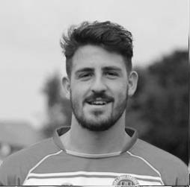
Hopefully we can continue this run and keep adding points to the table. The gaffer is a firm believer in taking each game as it comes and that's certainly helping relax us boys!

Lastly, thank you for all the messages I received for my birthday, each one was much appreciated!

COME ON YOU SALTS!

Ant

Results and Fixtures
Combined Counties League – Tuesday 7th October
Bedfont Sports | 1-3 | Knaphill
Camberley Town | 1-1 | Horley Town
Epsom & Ewell | 1-0 | Mole Valley SCR
Combined Counties League – Wednesday 8th October
Guildford City | 0-1 | Raynes Park Vale
Combined Counties League Cup Second Round – Saturday 11th October
Sheerwater | V | Mole Valley SCR
Combined Counties League – Saturday 11th October
Chertsey Town | V | Camberley Town
Cove | V | Colliers Wood United
Epsom & Ewell | V | Bedfont Sports
Farnham Town | V | Westfield
Guildford City | V | Frimley Green
Hanworth Villa | V | Badshot Lea
Horley Town | V | Hartley Wintney
Knaphill | V | Windsor
Molesey | V | Raynes Park Vale
Spelthorne Sports | V | Ashford Town (Mx)
Combined Counties League Cup Second Round – Tuesday 14th October
Alton Town | prov | Farnham Town
Badshot Lea | V | Dorking
Bedfont Sports | V | Cove
Camberley Town | V | Molesey
Chertsey Town | V | Windsor
Cobham | V | Horley Town
Epsom & Ewell | V | Knaphill
Frimley Green | V | Spelthorne Sports
Hanworth Villa | V | Guildford City
Westfield | V | Farleigh Rovers
Combined Counties League Cup Second Round – Wednesday 15th October
Epsom Athletic | V | Banstead Athletic
Combined Counties League – Saturday 18th October
Badshot Lea | V | Knaphill
Camberley Town | V | Raynes Park Vale
Epsom & Ewell | V | Ashford Town (Mx)
Frimley Green | V | Westfield
Guildford City | V | Bedfont Sports
Hartley Wintney | V | Farnham Town
Horley Town | V | Molesey
Mole Valley SCR | V | Colliers Wood United
Spelthorne Sports | V | Cove
Windsor | V | Hanworth Villa

First Eleven Appearances - (max 15 inc Mole Valley SCR)
Name | Debut | 2014/15 |  |  |  | Career Totals
Name | Debut | App | Sub | Total | Goals | App | Sub | Total | Goals
BROWN Oshane* | 30/08/2014 | 2 | 0 | 2 | 0 | 2 | 0 | 2 | 0
CURRIE Sam | 04/08/2012 | 2 | 0 | 2 | 0 | 96 | 5 | 101 | 2
DEAN Dan | 02/08/2014 | 13 | 0 | 13 | 0 | 13 | 0 | 13 | 0
DEWAR Ali | 29/10/2011 | 4 | 1 | 5 | 3 | 54 | 30 | 84 | 10
DOUGLIN Karl* | 03/08/2013 | 1 | 0 | 1 | 1 | 41 | 3 | 44 | 14
DOWNS Carl* | 17/09/2011 | 4 | 1 | 5 | 0 | 94 | 13 | 107 | 2
EACOTT Michael | 02/08/2014 | 13 | 0 | 13 | 0 | 13 | 0 | 13 | 0
FARRELL Matt | 02/08/2014 | 14 | 1 | 15 | 2 | 14 | 1 | 15 | 2
FERDINANDO Matt | 20/09/2014 | 3 | 2 | 5 | 0 | 3 | 2 | 5 | 0
GAFFNEY Luke | 16/08/2014 | 6 | 1 | 7 | 0 | 6 | 1 | 7 | 0
HARPER Tommy | 15/04/2014 | 1 | 0 | 1 | 0 | 2 | 1 | 3 | 0
HAYWARD Ben | 07/03/2007 | 5 | 0 | 5 | 0 | 241 | 28 | 269 | 18
HOADLEY Harry | 15/04/2014 | 6 | 1 | 7 | 0 | 7 | 1 | 8 | 0
HOUGH Kyle | 14/08/2007 | 13 | 0 | 13 | 4 | 267 | 12 | 279 | 141
JARMAN Mark | 08/08/2009 | 2 | 4 | 6 | 0 | 133 | 50 | 183 | 76
MARVELL Dale | 15/01/2000 | 9 | 3 | 12 | 5 | 259 | 43 | 302 | 85
MURPHY George | 28/03/2013 | 10 | 1 | 11 | 1 | 51 | 5 | 56 | 3
MUTIMA Lionel | 05/08/2014 | 4 | 2 | 6 | 0 | 4 | 2 | 6 | 0
NELMES Elliott* | 05/08/2014 | 2 | 0 | 2 | 0 | 2 | 0 | 2 | 0
PANAYI Anthony | 14/11/2010 | 8 | 1 | 9 | 0 | 135 | 15 | 150 | 4
ROBINSON Matt | 01/12/2012 | 1 | 0 | 1 | 0 | 2 | 3 | 5 | 1
ROBINSON Sam | 22/10/2011 | 9 | 1 | 10 | 4 | 33 | 4 | 37 | 9
SHAW Ollie | 20/09/2014 | 0 | 4 | 4 | 0 | 0 | 4 | 4 | 0
SMITH Taylor | 02/08/2014 | 11 | 0 | 11 | 5 | 11 | 0 | 11 | 5
TANTON Matt | 02/08/2014 | 9 | 2 | 11 | 1 | 9 | 2 | 11 | 1
TAYLOR James | 26/08/2013 | 10 | 1 | 11 | 1 | 27 | 7 | 34 | 2
VAN GELDER Julian* | 12/09/2006 | 0 | 1 | 1 | 0 | 0 | 2 | 2 | 0
WHITE Sean | 02/08/2014 | 3 | 6 | 9 | 2 | 3 | 6 | 9 | 2
* Player has left the club

From the back of the Stand
Epsom & Ewell 1-0 Mole Valley SCR – Combined Counties League
Tuesday 7th October 2014
Report by George Holland
The Salts moved up to 7th place with this hard earned win, in an evenly matched local derby. The crowd of 57 included 2 AFC Wimbledon fans, and Dixie Dean, Manager of Lingfield, our opponents in the 1st round of the F.A. Vase.

Epsom made hard work of it at times, giving the ball away occasionally, when a simple pass looked easier. And shooting on sight at times, which proved to be non-productive. We also got caught in their offside trap frequently.

Valley, for their part, proved to be feisty in their challenges, and quite vociferous in their opinions of the Referee's decisions, one example being when they were reduced to 10 men in the last 13 minutes, when it got rather attritional.

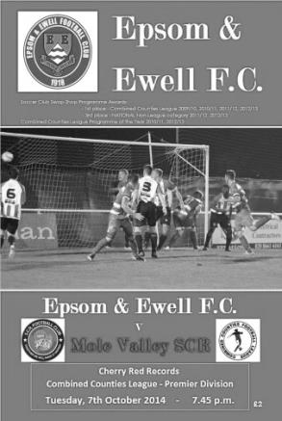
Valley had the first real attack on goal on 7 minutes with a header off target, followed by another attack that was snuffed out. Epsom countered with a low cross from James Taylor that was cleared. However, The Salts took an 11th minute lead after Dale Marvell's shot was charged down, the ball being scrambled around and cleared before being played back in to Hough. He steadied himself and curled a sweet left footed chip into the bulging net, giving the keeper no chance from the edge of the area. A trademark quality goal from a quality player.

Epsom started to dominate now. Matt Ferdinando just failed to reach Taylor's long ball on 15 minutes, and Marvell's free kick on 22 minutes was cleared off the line in a goalmouth scramble. A minute later Epsom should have doubled the lead when a corner was met by Hough's header to divert it against the far post. And on 25 minutes Robinson's cross, under pressure, just missed the far post.

Valley countered with a shot dipping over the bar on 33 minutes. However, they forced Michael Eacott into two great saves on 35 and 37 minutes. We finished the half on the offensive with Hough losing out to the keeper in a chase for the ball, and a free kick from the centre circle that was cleared.

In the second half, Hough just failed to reach a cross on 51 minutes, before Eacott punched a cross clear under pressure, the resulting shot going wide. Valley came back again with weak efforts, before Matt Farrell, Ferdinando, and Farrell again, missed good chances with the Valley defence under pressure. On 69 minutes George Murphy and Eacott combined to thwart an onrushing forward, with the Referee waving away penalty claims.

A valley defender was then dismissed on 77 minutes for serious foul play, when things got rather feisty. Both sides kept going forward wasting chances, but Epsom could not make their numerical advantage count. On 87 minutes, Hough did attempt to chip the keeper from the edge of the area, which he was equal to in catching it. Going into injury time, there was another altercation between the players with Marvell and an opponent both getting booked for their troubles. This gave us our third consecutive League win.

Team: Michael Eacott, James Taylor, Luke Gaffney, George Murphy (c), Dan Dean, Matt Tanton, Matt Ferdinando, Matt Farrell, Matt Robinson, Kyle Hough, Dale Marvell.
Sub: Ollie Shaw for Matt Robinson (82 minutes).

Our Match Sponsors
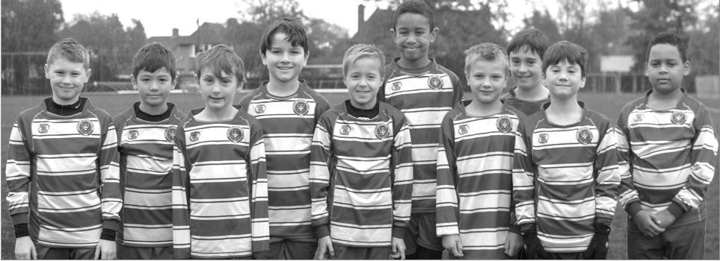
EPSOM & EWELL COLTS F.C. - 2014/2015

The Colts are pleased to be able to sponsor today’s game this afternoon. We wish the first team all the very best both today against Bedfont Sports and for the rest of the season.

It has been a while since I last wrote in the programme so a quick update on the latest Colts news. Last season was our most successful on the pitch with 3 league winners and 3 cup winners as well as another team being cup finalists.

This season we have 29 teams competing in 4 different leagues at ages from U8 to U18 which includes 4 girls teams from U9 to U12. The majority of clubs in the area seem to be struggling for new members but we have been bucking the trend and now have over 350 players across all ages. We are represented at every age group and at U8 and U14 we have 4 teams.

It is still the beginning of our season but even so the majority of teams have already seen some success and so the outlook for the season is good. As always are one of the main problems we have is pitches and so the news that progress is being made on the possibility of a ground for the club is very welcome.

As some of you will know I have now become part of the Club Committee to act as a link between the Colts and the First team and I will try my best to ensure that we remain closely connected as a club.

I hope that you all enjoy the game this afternoon and I look forward to giving you further reports on the Colts when I can.

Mike Lovett
Chairman, Epsom and Ewell Colts

020 8393 4576

Club Records - 11th October
Date | Day | Competition |  | Opponents |  | Scorers
11/10/24 | Sat | Friendly | A | Metrogas | 6-0 | R.Marlow (3), R.Sperring, J.Parr, F.Kent
11/10/30 | Sat | Amateur Cup 1q | A | West Norwood | 3-2 | F.Behn (2), G.Mackesy (pen)
11/10/47 | Sat | Amateur Cup 1q | H | Carshalton Athletic | 2-6 | T.Rochester (pen), W.Webber
11/10/52 | Sat | Corinthian League | H | Erith & Belvedere | 0-1
11/10/58 | Sat | Amateur Cup 1q | H | Cobham | 3-0 | J.Bryson, I.McTear (pen), T.Higgins
11/10/69 | Sat | Amateur Cup 1q replay | H | Whitehawk | 2-2+ | K.Jolly, D.Morrish
11/10/75 | Sat | Athenian League 2 | H | Feltham | 4-2 | D.Worby, J.Eales, T.Tuite, A.Reid
11/10/80 | Sat | Isthmian League 1 | H | Camberley Town | 5-1 | T.Coombe (2), J.Hunn, L.Peck, D.Burke
11/10/83 | Tue | Isthmian League 1 | H | Leatherhead | 2-0 | S.Hill (2)
11/10/86 | Sat | Isthmian League 1 | A | Leyton Wingate | 0-4
11/10/88 | Tue | Isthmian League 2s | H | Yeading | 2-0 | C.Hadingham (2)
11/10/98 | Sun | F.A. Vase 2q | H | Bracknell Town | 2-1 | T.Boorman, K.Webb
11/10/03 | Sat | Isthmian League 1s | H | Met Police | 2-5 | J.Rogers, S.Huckle
11/10/08 | Sat | Combined Counties  Premier Division | H | Hartley Wintney | 5-0 | R.Burns, G.McLaughlin (2), D.Marvell, K.Hough
11/10/11 | Tue | Combined Counties  Premier Division | A | Dorking | 1-1 | A.Myers
Historical Decades
90 years ago – Epsom Town
11/10/24 | Sat | Friendly | A | Metrogas | 6-0 | R.Marlow (3), R.Sperring, J.Parr, F.Kent
80 years ago – Epsom F.C.
13/10/34 | Sat | F.A. Cup 2q | H | Guildford City | 2-4 | E.Hannam, T.Dunne
70 years ago – War time Epsom Town
14/10/44 | Sat | South Eastern Combination | A | Erith & Belvedere | 0-2
60 years ago – Epsom F.C.
09/10/54 | Sat | Corinthian League | H | Grays Athletic | 2-4 | T.Wright (2)
50 years ago – Epsom & Ewell
10/10/64 | Sat | Amateur Cup 1q | A | Westfield | 1-0 | B.Mackay
40 years ago – Epsom & Ewell
12/10/74 | Sat | Surrey Senior League  Charity Cup 1 | H | Westfield | 6-2 | J.Eales (3), T.Tuite, T.Lee (pen), D.Worby
30 years ago – Epsom & Ewell
09/10/84 | Tue | Isthmian League Cup 1 | A | Dorking | 4-0 | S.Hill (2), S.Milton, T.Tuite
20 years ago – Epsom & Ewell
08/10/94 | Sat | Isthmian League 3 | A | Northwood | 0-0
10 years ago – Epsom & Ewell
09/10/04 | Sat | Isthmian League 2 | A | Wembley | 0-1

History Corner – 11th October
90 years ago today Epsom Town had a day off from League action and arranged a friendly against Metrogas, the London League side. The game was played at their ground on the Old Kent Road, but we simply brushed them aside by six clear goals. Reg Marlow scored a hat trick against the gasmen, but by the time we were promoted to the London League in 1927 they had departed the scene for a lower level of play.

80 years ago this week there were 3,300 present to witness another great win in the F.A. Cup. Unfortunately, Guildford City hadn’t read the script and the professional Southern League side came away from West Street with a 4-2 win. There would be no trip to the First round for us that year, although Guildford would get there.

67 years ago today Carshalton Athletic put us out of the Amateur Cup with a 6-2 win. All six goals were scored by Len Chatterton, who would go on to Crystal Palace, eventually becoming their groundsman too before his death last year at the age of 91.

45 years ago today Whitehawk visited us for the replay of our Amateur Cup tie. What neither team realised at the time was that not only would this match fail to separate the teams, but a midweek second replay at Horsham would also be unsuccessful in providing a winner. Eventually we would progress with a 1-0 win there in a third replay, only to be defeated by Tooting & Mitcham in the next round anyway!

40 years ago this week Johnny Eales got a hat trick as last season’s Champions, Westfield were crushed 6-2 in the League Charity Cup.

39 years ago today we defeated Feltham 4-2 in an Athenian League match. Nothing particularly significant in that, except a team photo was taken that day, showing the one time central defender Dave Worby played alongside youngster Tony Coombe who made his debut. (Coombe second from left, back row, Worby sixth in line, back row)

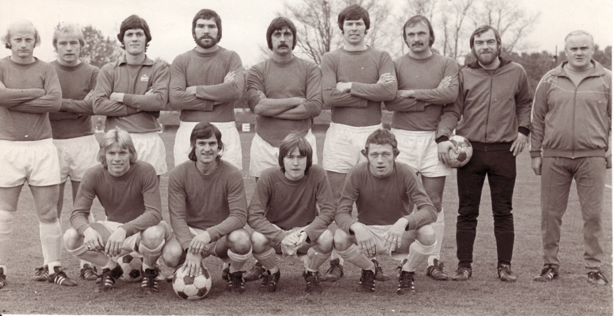
30 years ago this week we cruised past Dorking on our way to the Quarter-Finals of the League Cup. Steve Hill scored twice in this First Round tie at Meadowbank and Bishops Stortford and Heybridge Swifts were beaten before Staines Town defeated us 1-0 after extra time at West Street.

Centre page for results

Centre page for results

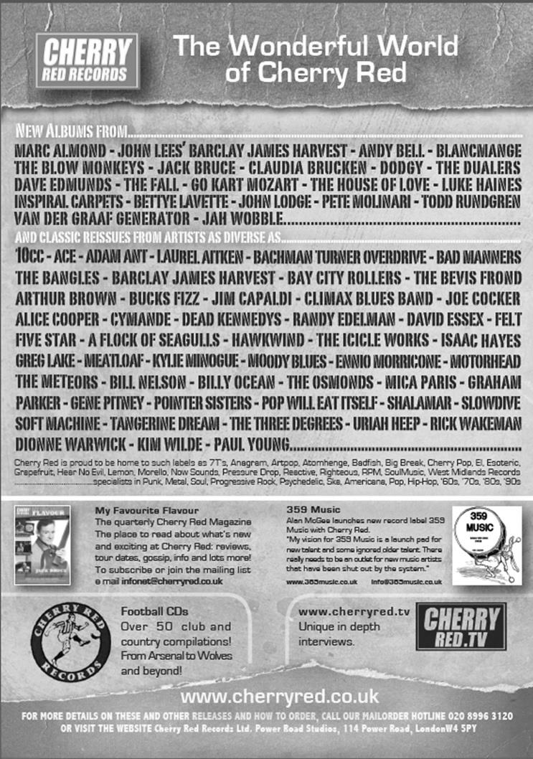

F.A. Vase
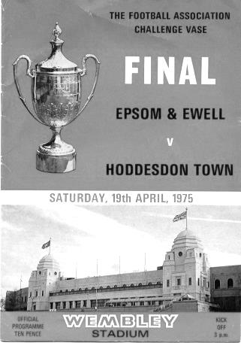
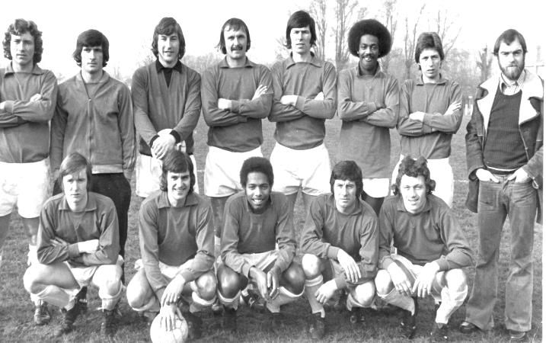
Second Qualifying Round Results – 4th October
Colliers Wood United | 2-1 | Shoreham
Cray Valley (PM) | 0-2 | Horley Town
Farnham Town | 2-1 | Milton United
Flackwell Heath | 5-0 | Frimley Green
Highworth Town | 2-1+ | Hartley Wintney
Spelthorne Sports | 2-1 | Risborough Rangers
Molesey | 1-2 | Greenwich Borough
Raynes Park Vale | 2-1 | Epsom Athletic
Rothwell Corinthians | 0-1 | Bedfont Sports
Windsor | 4-0 | Binfield
Woodley Town | 0-2 | Knaphill
First Round Proper Draw – 1st November
Ashford Town (Mx) | V | Loxwood
Chertsey Town | V | Horley Town
Chessington & Hook United | V | Camberley Town
Colliers Wood United | V | Ringmer
Farnham Town | V | Abingdon United
Horsham YMCA | V | Bedfont Sports
Lingfield | V | Epsom & Ewell
Littlehampton Town | V | Guildford City
Lordswood | V | Knaphill
Pagham | V | Spelthorne Sports
Raynes Park Vale | V | Westfield
Windsor | V | Highworth Town
Hanworth Villa are exempted to the Second Round

Player Sponsorship
Here is the latest list showing all of the players and Management available for sponsorship. Sponsorship costs £40 so if you want to help the club, the player and get your name in the programme for the season, just let us know.

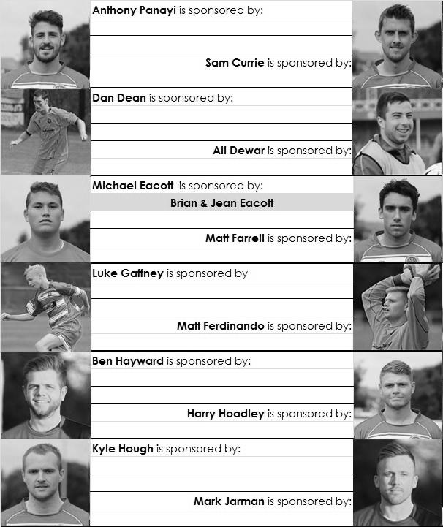

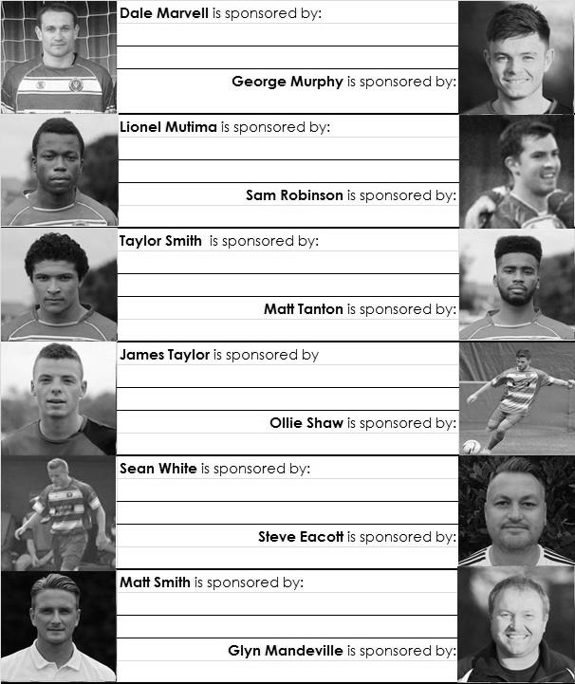

We are not fussy; we’ll take cash or a cheque! Any donation will help the club and is much appreciated.

Every Opponent A-Z
Over the years we have played many, many different opponents. Exactly how many is a difficult question, as it all depends on your definition. Are Camberley & Yorktown different to Camberley Town, or are Epsom Town different to Epsom F.C. or Epsom & Ewell F.C.?

In my analysis I have classed them as the same team, and will work through them all from A to Z. Some we have played many times, whilst others we have met maybe just once or twice. Enjoy!

Leytonstone and Ilford: Played 9 - W1 D3 L5 - F7 A18 - PPG - 0.67 - Awful

The story of Leytonstone, Ilford, Ilford / Leytonstone, Leytonstone / Ilford, then finally Leytonstone & Ilford is a messy one and I’m not going to go into detail here except to summarise by saying that both clubs were very big Amateur teams and former Amateur Cup winners, before circumstances befell the Ilford ground at Lynn Road, followed a few years later by a new road going through Granleigh Road, home to Leytonstone. They all decamped to Walthamstow Avenue where they merged into Redbridge Forest before losing Walthamstow’s famous Green Pond Road site too!

Eventually that new club joined with Dagenham to provide us with the League club we know today, but I doubt that any supporters from the old days are Dagenham & Redbridge supporters now. In fact, Ilford, under the guidance of long serving supporter and former Isthmian League official Len Llewellyn reformed and now have a new site of their own.

Our first meeting with either club came on 13th December 1930 and was arguably the biggest game ever staged at West Street to that date. We had reached the first round of the Amateur Cup for the first time ever, which was the last 64 in the Country. At that stage, the big boys came into the competition, and they didn’t come much bigger than Ilford, the current Amateur Cup holders!

A substantial number packed themselves into the ground where they witnessed the home side taking an early lead. We held it until half time and then shortly afterwards, increased it. However, within fifteen minutes the tide had turned and we were 3-2 down, eventually losing 5-2. Maybe it was just down to a lack of experience!

Our next meeting was for an even bigger match, on 11th November 1933 when we met Leytonstone in the final qualifying round of the F.A. Cup, again at West Street. This match took a contrary path to the contest against Ilford as the visitors led at the half, but in the second period, we flew at them and turned the game around to win 3-1!

Our next meetings did not come for 46 years and then there were two in the same week! By now Ilford had declined as an Isthmian League powerhouse and were just making up the numbers in Division One, having lost their ground at Lynn Road and relocated to Granleigh Road in preparation for the merger that would follow the next season. We lost there 2-1 but bounced back five days later on a Thursday night to win 3-1 at West Street with both matches taking place in April of 1979.

The merged club; Ilford / Leytonstone to start with, but soon amended with the teams in the opposite order were a different proposition and would become Champions, defeating us twice by the odd goal; 0-1 at West Street and 3-2 in Leytonstone.

However, this team were destined for greater things and under the guidance of a promising young Manager by the name of John Still they had the season to end all seasons in 1981/82, when they reached the First Round of the F.A. Cup, but in addition, won the Isthmian League, the Isthmian League Cup, the Essex Senior Cup and the London Senior Cup!!

We met them in the last 16 of the London Senior Cup, just one week after our narrow defeat by Altrincham in the F.A. Trophy. A decent crowd at West Street watched us battle them all the way to extra time, but in the final period, three goals for the visitors gave the score line a flattering look. They were the better side, but never by that amount.

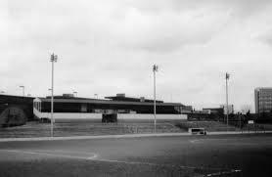
Following our promotion in 1984 we met as equals and this time the timing was on our side. After waiting until November for our first win, it had arrived three days before this game and now full of confidence we destroyed them on their own patch with the deadly pairing of Tommy Tuite and Steve Hill getting all five in our 5-1 win; Hill with the hat trick this time.

What we didn’t realise at the time was that we would never even score against them again. We drew 0-0 in the return and they went down, but we weren’t in the top flight for long ourselves and when we dropped for 1986/87 we found them in good form again and they defeated us home and away by two goals to nil in both games.

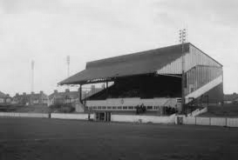
The away fixture was played at Leyton Wingate’s Hare and Hounds ground as the famous side had by now lost their site at Granleigh Road. They went up this season and the rest is documented earlier in this article.

However, we went down and would never meet them again, although we did play the reformed Ilford during the 2004/05 season in the Ryman League Division Two, once at their new Cricklefields ground, losing a tight match 2-0 and then more conclusively at home in the March by 0-3 as they went straight up.

Ilford survived in the Ryman League for a few seasons but now reside in the Essex Senior League and maybe one day we will meet again.

Top: The main stand at Granleigh Road, Leytonstone – Bottom: Lynn Road, Ilford F.C.

Match and Ball Sponsorships – 2014/15
Opponent | Date | Match Sponsor | Ball Sponsor
Raynes Park Vale | 05/08/14 | Club President - Stella Lamont
Horley Town | 25/08/14 | Epsom & Ewell F.C. Management Committee
Croydon (FAC) | 30/08/14 | Media Officer - Richard Lambert
Frimley Green | 13/09/14 | Dave Gaffney and friends
Guildford City | 30/09/14 | The Jarman family
Mole Valley SCR | 07/10/14 | Mark and Carmel Murphy
Bedfont Sports | 11/10/14 | Epsom & Ewell F.C. Colts
Knaphill (LC) | 14/10/14 | Geoff and Steve Dyke
Ashford Town (Mx) | 18/10/14
Chertsey Town | 28/10/14
Spelthorne Sports | 11/11/14
Molesey | 22/11/14 | Provisional and dependent on any Vase progress
Camberley Town (SSC) | 02/12/14 | Provisional date
Hanworth Villa | 06/12/14
Windsor | 03/01/15
Farnham Town | 17/01/15
Westfield | 31/01/15
Camberley Town | 07/02/15
Hartley Wintney | 21/02/15
Cove | 07/03/15
Badshot Lea | 21/03/15
Colliers Wood United | 04/04/15
Knaphill | 18/04/15
For League, League Cup and Surrey Senior Cup Matches:

Match sponsorship - £40.00 Match ball sponsorship - £25.00.
Combined Offer of Match and Match Ball sponsorship for £55.00.

For F.A. Cup and F.A. Vase matches:

Match sponsorship - £50.00 Match ball sponsorship - £30.00.
Combined Offer of Match and Match Ball sponsorship for £65.00.
----------------------------------------------------------------------------------------------------------------------------
Sponsorship includes

Admission, programmes, advertising (if required) and hospitality.

If you are interested, just speak to a Committee Member, you know where we are!
Alternatively, drop me an email at: richard.c.lambert@gmail.com

Our New Website
Have you seen our website lately?

For those who are unaware, our website, now over a year old, contains everything you could possibly want to know about the club and an enormous amount you may not have been aware of!

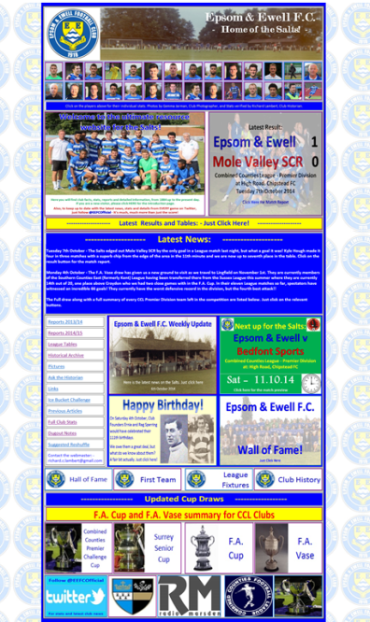
Our previous site still exists, but as a photo archive only, housing the enormous wealth of pictures provided by Gemma Jarman, our Club photographer. In addition, there are over a thousand historical images of teams, players, action shots and programme covers.

As you can tell from the screenshot of our front page, there is a substantial amount of information all available at the touch of a button, which is also very useful if you own one of those new touchscreen personal computers that are becoming more and more popular these days.

If you are a supporter, please pass the address on to anyone you know that has ever expressed an interest in the club, especially those who don’t visit any more. You never know, some of them might be inspired to come along too, and bring their friends etc.

http://www.eefconline.co.uk/

Combined Counties League – Premier Division
Saturday, 11th October 2014 - Kick-off 3.00 p.m.
Epsom and Ewell  (Royal Blue & White hoops) | V |  | Bedfont Sports  (Red and Black)
 | NUMBERS
Michael Eacott |  |  | Josh Richardson
James Taylor |  |  | Tim Pitt
Luke Gaffney |  |  | Phil Dexter
© George Murphy |  |  | Julius Mngadi
Dan Dean |  |  | Dean Thomas
Matt Tanton |  |  | Jack Harman
Sam Robinson |  |  | Adam Fearn
Matt Farrell |  |  | Norman Bokowski
Taylor Smith |  |  | Jordan Wain
Kyle Hough |  |  | Adam Roberts
Dale Marvell |  |  | Jamie Read
Mark Jarman |  |  | Jordan Esprit
Lionel Mutima |  |  | Darryl Sanders
Matt Ferdinando |  |  | David UnwinAlex Wines
Ollie Shaw |  |  | Brad Scott
Anthony Panayi |  |  | Byron Obinya
Ben Hayward |  |  | Robbie Sitch
Ali Dewar |  |  | Taylor Green
Matt Robinson |  |  | Grant Cooper
Glyn Mandeville | MANAGER |  | Mick Snowden / Craig Woodbridge
Matt Smith | ASSISTANT / HEAD COACH |  | Ian Barrado / Simon Brand
Steve Eacott | GOALKEEPING COACH
REFEREE: S.Gill (Iver, Bucks)
ASSISTANTS: M.Ford (Sutton), S.Potter (Sutton)
Today’s Match and Match Ball are sponsored by
The Epsom & Ewell Colts Football Club

OUR NEXT VISITORS TO HIGH ROAD
Knaphill
Tuesday 14th October 2014 - Kick-off 7.30 p.m.
Combined Counties League Cup – Second Round

